MT7620N 模块布局

一、尺寸及布局
关键器件布局和尺寸图：

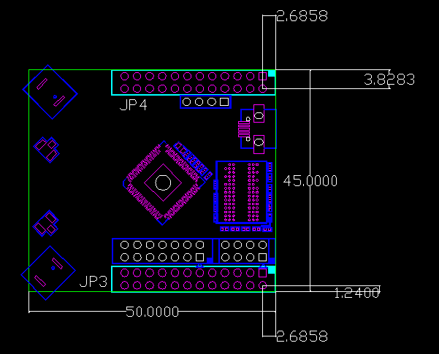

板子最上方和最下方为两条间距为2.54mm的双排24pin插针，用来引出MT7620上所需要的引脚。这两个连接器在bottom面。
标准14pin的JTAG接口，间距为2.54mm； SPI编程器引脚，用来给SPI Flash进行编程，这两个连接器在JP3附近，在top面
板子右侧上方为Micro USB座，用来给板子供电，同时也连接到MT7620的USB接口上。

二、核心资源
项目 | 要求
CPU | MT7620N
内存 | DDR-2，512Mb
SPI Flash | 128Mb

三、JTAG调试接口定义
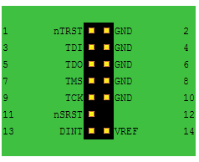
参考：http://www.jtagtest.com/pinouts/ejtag

四、SPI编程接口定义
SPI编程接口用来往SPI Flash里写入bootloader（需要知道SPI Flash的具体型号）。
注：此处的引脚指提Flash芯片所对应的引脚


五、外接引脚定义
JP3连接器引脚定义：
引脚 | 名称 | GPIO共享定义 | 引脚功能
1 | 3.3VD | Power | Power
2 | 3.3VD | Power | Power
3 | GND | GND | GND
4 | GND | GND | GND
5 | GND | GND | GND
6 | WLED_N | GPO#72 | WLAN Activity LED
7 | RXD2 | GPIO#16 | UART Lite RXD
8 | TXD2 | GPIO#15 | UART Lite TXD
9 | SPI_MISO | GPIO#6 | Master output/Slave input
10 | SPI_MOSI | GPO#5 | Master input/Slave output
11 | SPI_WP | GPO#39 | GPO function
12 | SPI_HOLD | GPO#38 | GPO function
13 | SPI_CLK | GPO#4 | SPI clock
14 | SPI_CS1 | GPIO#37 | SPI chip select1
15 | I2C_SCLK | GPIO#2 | I2C Clock
16 | I2C_SD | GPIO#1 | I2C Data
17 | GPIO0 | GPO#0 | GPO0 (output only)
18 | ANT_TRN | GPO#19 | Positive signal for antenna T/R switch
19 | ANT_TRNB | GPO#18 | Negative signal for antenna T/R switch
20 | WDT_RST_N | GPIO#17 | Watchdog Reset
21 | GND | GND | GND
22 | EPHY_LED0_N_JTDO | GPIO#40 | 10/100 PHY Port #0 activity LED, JTAG_TDO
23 | EPHY_LED1_N_JTDI | GPIO#41 | 10/100 PHY Port #1 activity LED, JTAG_TDI
24 | EPHY_LED2_N_JTMS | GPIO#42 | 10/100 PHY Port #2 activity LED, JTAG_TMS
25 | EPHY_LED3_N_JTCLK | GPIO#43 | 10/100 PHY Port #3 activity LED, JTAG_CLK
26 | EPHY_LED4_N_JTRST_N | GPIO#44 | 10/100 PHY Port #4 activity LED, JTAG_TRST_N

JP4连接器引脚定义：
引脚 | 名称 | GPIO共享定义 | 引脚功能
1 | GND | GND | GND
2 | D- | I/O | USB Port0 data pin Data-
3 | PA_PE_G0 | GPIO#20 | 0 V to 3.3 V control for external PA0
4 | D+ | I/O | USB Port0 data pin Data+
5 | PA_PE_G1 | GPIO#21 | 0 V to 3.3 V control for external PA1
6 | GND | GND | GND
7 | MDI_RN_P0 | N/A | 10/100 PHY Port #0 RXN
8 | MDI_RP_P0 | N/A | 10/100 PHY Port #0 RXP
9 | MDI_TN_P0 | N/A | 10/100 PHY Port #0 TXN
10 | MDI_TP_P0 | N/A | 10/100 PHY Port #0 TXP
11 | MDI_RN_P1 | N/A | 10/100 PHY Port #1 RXN
12 | MDI_RP_P1 | N/A | 10/100 PHY Port #1 RXP
13 | MDI_TN_P1 | N/A | 10/100 PHY Port #1 TXN
14 | MDI_TP_P1 | N/A | 10/100 PHY Port #1 TXP
15 | MDI_RN_P2 | N/A | 10/100 PHY Port #2 RXN
16 | MDI_RP_P2 | N/A | 10/100 PHY Port #2 RXP
17 | MDI_TN_P2 | N/A | 10/100 PHY Port #2 TXN
18 | MDI_TP_P2 | N/A | 10/100 PHY Port #2 TXP
19 | MDI_RN_P3 | N/A | 10/100 PHY Port #3 RXN
20 | MDI_RP_P3 | N/A | 10/100 PHY Port #3 RXP
21 | MDI_TN_P3 | N/A | 10/100 PHY Port #3 TXN
22 | MDI_TP_P3 | N/A | 10/100 PHY Port #3 TXP
23 | MDI_RN_P4 | N/A | 10/100 PHY Port #4 RXN
24 | MDI_RP_P4 | N/A | 10/100 PHY Port #4 RXP
25 | MDI_TP_P4 | N/A | 10/100 PHY Port #4 TXP
26 | MDI_TN_P4 | N/A | 10/100 PHY Port #4 TXN

六、USB
采用USB Micro座，引出MT7620N的USB接口功能，同时可以给核心板供电。

七、天线
天线采用板载天线，同时提供IPEX表贴天线座，用于需要外接天线的场合。

